

4 Animals

Thanks for downloading the asset , for any help contact me at [madfireongames@gmail.com](mailto:madfireongames@gmail.com)

Scripts

GameManager – This script controls the game from start to end. It keep track of game , saves and loads the data , and do many important functions.

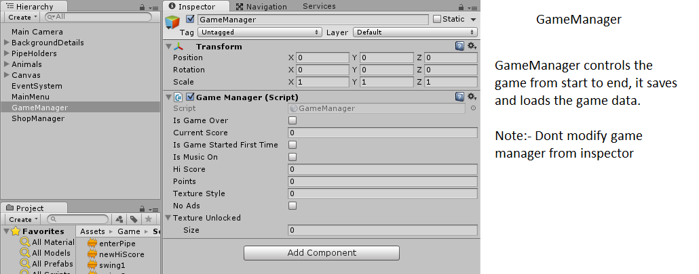

MainMenu- This script controls the function of the buttons in the main menu. Here you assign the buttons are write the function for them.

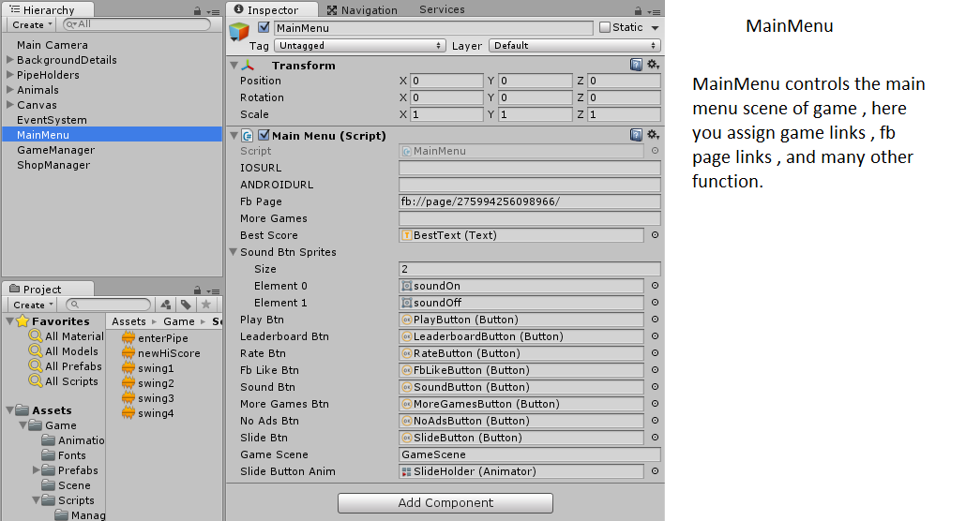

InGameGui- This script controls the gui of the game play scene.

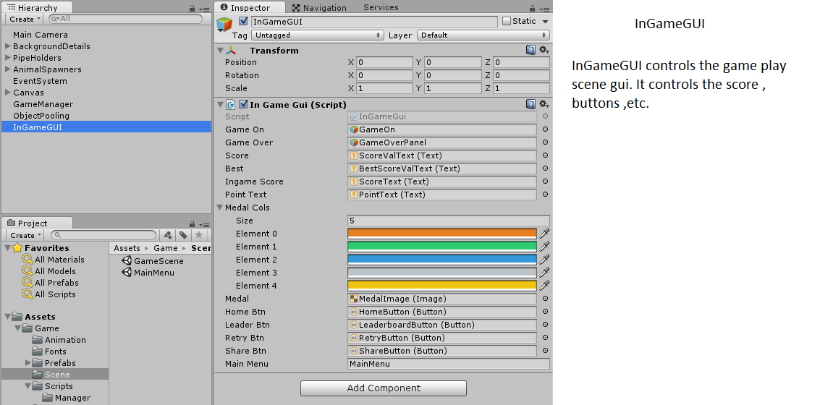

ObjectPooling – This creates the clone of object to be used repeatedly in the game. This help in increase in the smoothness of game.

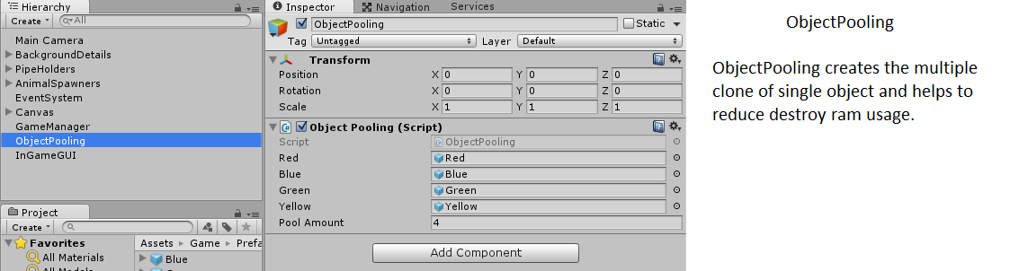

ShopManager – This script controls the in game shop.

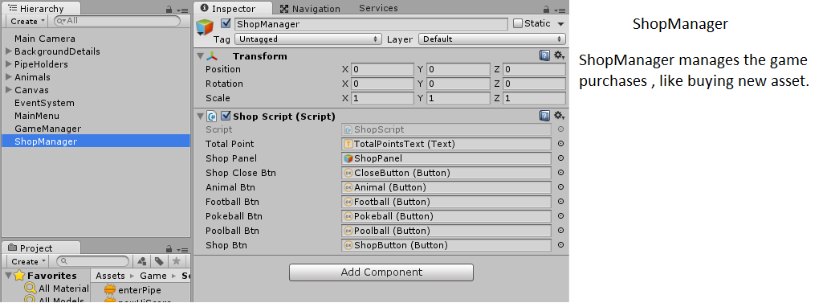

Important:- If you want animation of pipe you can go to “Pipe” gameobject and activate the “PipeAnim” and “Animator” component.

In unity 5.4+ you may see some error like this when you activate the animation.



But it has no effect on the game , I think its some kind of unity bug.